SOFTWARE DESIGN

S3-GROUP

wELLES,nICK n.H.M.

2022 - 2023

Table of content

User stories 2

Concepts 2

Concept diagram 2

ERD 3

Software architecture 3

# User stories

We created the user stories in GitHub. here we have a central place for all the documents and we can also easily share it with the client because it is easy to read.

These user stories are approved by the client and they help us get a clearer picture of the complete assignment and requirements.

[View file](https://github.com/WJJCN/Documentation/blob/main/Requirements.md)

# Concepts

## Concept diagram

To make it a little easier, and more visual for ourselves, we created a concept diagram. We inherited this from semester 2 but it seemed like a good activity to have a good understanding of exactly what to build. From the EER we created an ERD, that way we could set up a database and that way we also know how to set up the ORM.

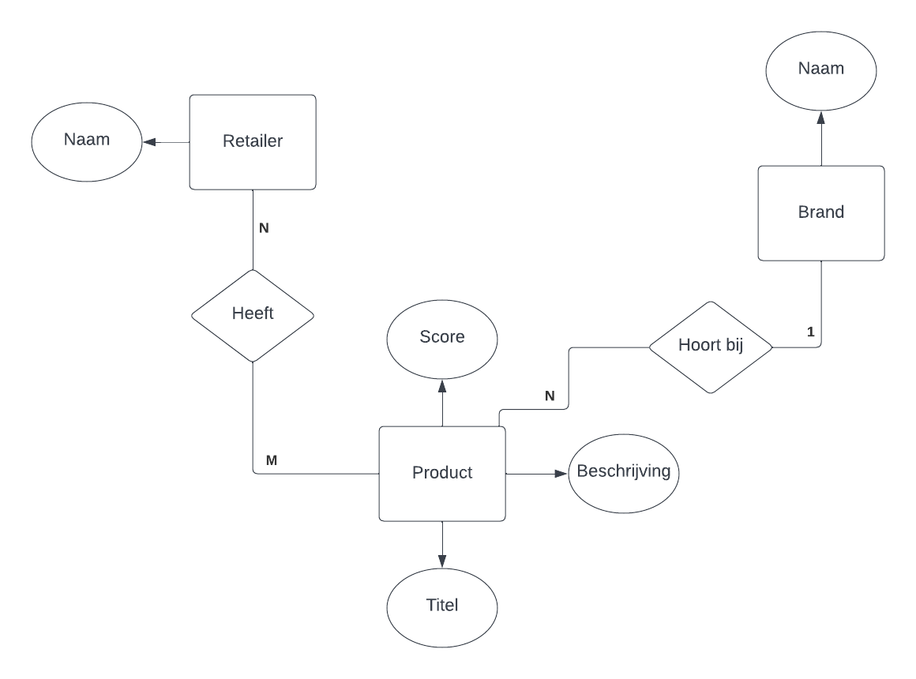

## ERD

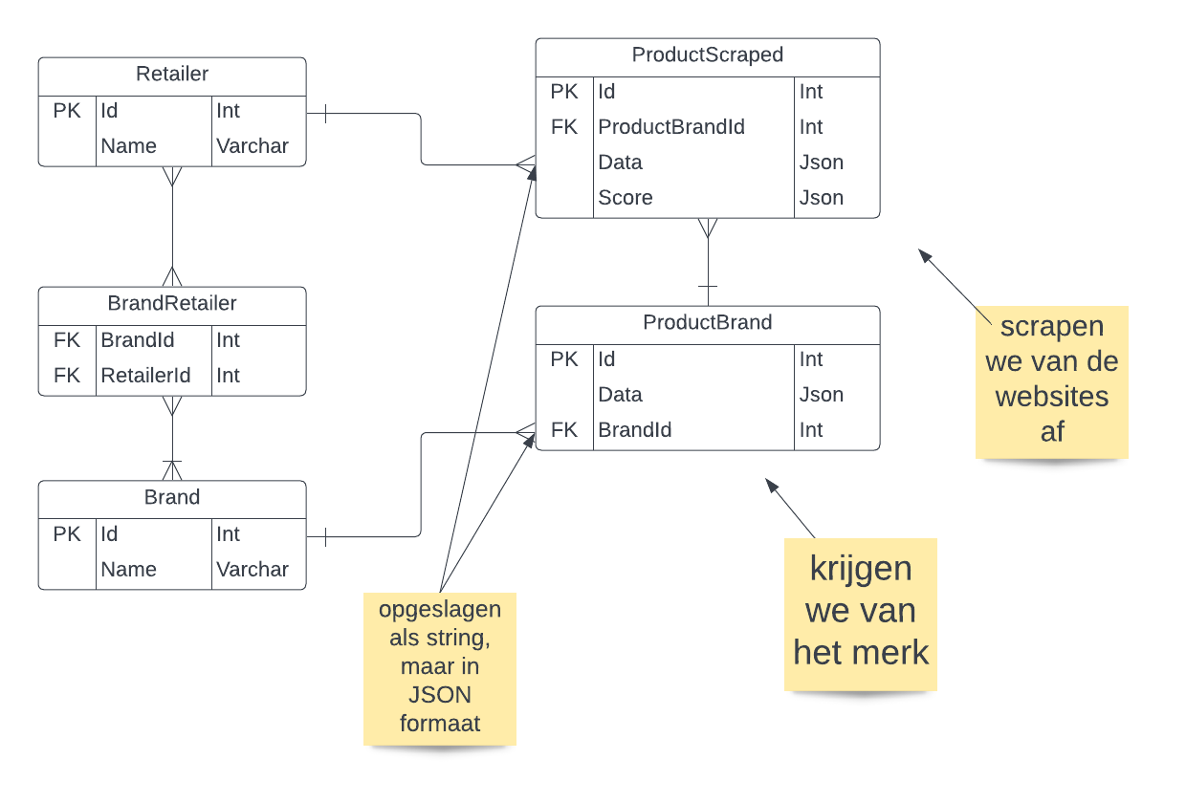

# Software architecture

…

